Project Report: FireLocator Application
To: Professor Spies Francois
From: Muhammad Omais Rana
Subject: Concise Report on the "FireLocator" App

1. Project Objective
The app's purpose is to find the GPS coordinates of a distant target (like a fire). It uses the phone's camera as a viewfinder and its sensors to calculate the target's location, then sends this data via SMS.

2. Technical Components
- UI (activity_main.xml): A ConstraintLayout to show the live camera feed from a PreviewView with a green crosshair View layered on top.
- Permissions (AndroidManifest.xml): Declared permissions for CAMERA, ACCESS_FINE_LOCATION (GPS), and SEND_SMS.
- Main Logic (MainActivity.java):
  - CameraX: Manages the live camera feed.
  - Location Services: Gets the phone's current GPS coordinates and altitude.
  - Sensor Manager: Gets the phone's orientation (compass azimuth and up/down pitch).
- Calculation (Point.java): Used the provided Point class to calculate the final destination coordinates.

3. How It Works
- Aim: The user points the phone's crosshair at the fire. The app is already tracking live GPS and sensor data.
- Capture: When the user presses "Send," the app instantly saves the phone's current GPS location, azimuth (direction), and pitch (angle).
- Calculate: The app performs two calculations based on the project's rules:
  - Distance: It uses the 1.5-meter phone height and the "pitch" angle to find the distance to the fire, assuming the ground is flat.
  - Coordinates: It feeds the user's location, the compass azimuth, and the calculated distance into the Point.java class to find the fire's exact GPS coordinates.
- Send: The app formats all this data (user location, fire location, azimuth) into a string and sends it as an SMS to 555-1234.

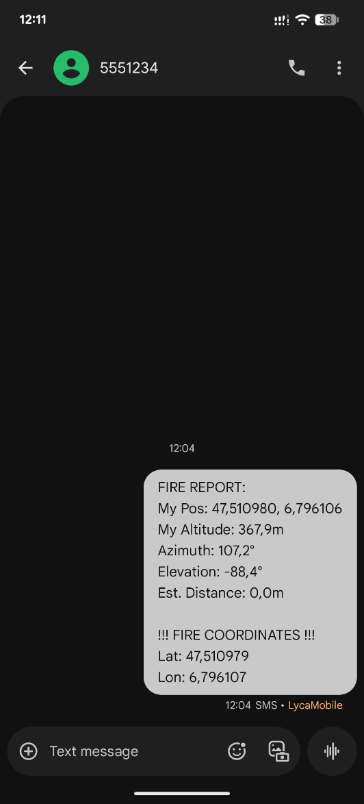
Figure 1. Tested on personal device

